Mountaineer Regional Service Committee
of Narcotics Anonymous
PO Box 2381
Morgantown, WV-2381
Email: mountaineer.region.web@gmail.com
Helpline: 304-344-4442
800-766-4442

MRSCNA Minutes
October 5, 2024

OFFICERS: REGIONAL COMMITTEE MEMBERS:
Chair: Daniel M NCASCNA: Shenna G.
Vice-Chair: LeeLee C Alt:
Secretary: Donna C. AFASCNA: Garrett N.
Treasurer: Brian A Alt: Heather S
NANA: Greg Y
RD: Dana S. Alt: Donn C.
RD Alt: R.D. C. METRO ASR: Brooke P.
Alt ASR: Liz F.
SUBCOMMITTEE CHAIRS: MANA: Cooper B.
Convention: Cooper B. Alt:
Literature: Inactive GTO: Andrew A.
PR: Shenna R Alt:
H&I: Daniel M. FANA: Theresa J
P&A: LeeLee C Alt:
Finance: Brian A. GMANA: Tory W
Phone Line: RD C. Alt:
Web Servant: Brooke P
Web Servant II: Tia M

MRSCNA OFFICER LIST
Chairperson
Daniel M.
Mcpherson21@hotmail.com
304-678-7706

Vice Chairperson
LeeLee C
Swvfh.lee@gmail.com
304-860-5535

Treasurer
Brian A
Akersbrian79@gmail.com
304-920-9787

Treasurer II
Candie B
Candie.43@yahoo.com
681-418-3034

Secretary
Donna C.
Mountaineer.region.sec@gmail.com
304-761-0611

RD
Dana S.
SUBCOMMITTEE CHAIRS

PR Chair
Shenna R
Sheshe05092@gmail.com
681-495-2331

Convention Chair
Cooper B.
Cpbenedict52@gmail.com
304-661-0507

Phone Line Chair
RD. C
ronnie.dael@gmail.com
304-228-0704

H&I Chair
Daniel M.
Mcpherson21@hotmail.com
304-678-7706

Web Servant
Brooke P
Bparker9094@gmail.com
304-995-96
Hepmejesus@gmail.com
321-446-0130

Web Servant
RD ALT Tia M
R.D. C. tiamiller5959@gmail.com
ronniedael@gmail.com 681-367-4030
304-228-0704

RCM AND RCM ALTS

AFASCNA Alt.
Garrett N. Heather S
Garrett.nunn@gmail.com statlerheather@gmail.com
740-350-0590 740-538-4997

METRO Alt.
Brooke P.
Bparker9094@gmail.com
304-995-9667

GTOASCNA Alt.
Drew Adkins
Adkinsandy105@gmail. Com
304-563-3009

MANA Alt.
Cooper B.
cpbenedict52@gmail.com
304-661-0507

NANA Alt.
Greg Y
gregfromniles@gmail.com
304-989-1493

NORTH CENTRAL WVASCNA Alt.
Shenna R Tia M
Sheshe05092@gmail.com tiamiller5959@gmail.com
681-495-2331 304-661-0507

FREEDOM AREA (FANA) Alt.
Theresa J
hendersontheresa243@gmail.com
304-362-1680

GMANA Alt.
Tory W.
Vw426@icloud.com
304-216-0870

Those in attendance to the MRSCNA meeting for October 5, 2024

- Cooper B. – Convention Chair, RCM MANA
- Shenna G. – NC RCM, Con. Merch Chair, PR Chair
- Greg Y. – RCM NANA
- Eric C – Convention Refreshments Vice
- Daniel M. – Chair, H&I Chair, Convention Reg. Vice
- Garrett N. – AFASCNA RCM, Convention Vice Chair
- Andrew A. – GTO RCM, Convention Refreshments Chair
- Megen P – Con Merch Vice, H&I Vice
- Tia M – Web Serv II, Conv Sec, NCWVA RCM ALT
- Brian A. – Treasurer I
- Heather S – RCM ALT AFASCNA
- Jerome C – Convention Audio Chair
- Brooke P – RCM Metro, Webservant I
- Donna C. – RSC Secretary, Convention Registration Chair
- Tory W. - GMANA RCM, PR Vice
- Theresa J – RCM FANA
- Candie B – Treasurer II

MRSCNA Minutes
October 5, 2024

- Opened with Prayer
- Twelve Traditions read
- Twelve Concepts read
- 8 RCM’s/ASR’s attended

Introductions

Secretary’s Report:
July 2024 RSC minutes were read and accepted by the body, with amendments. Read Over New Business Proposals from July 2024 RSC.

Old Business:

PROPOSAL#: 07-24-P1
MAKER: PR
PROPOSAL: To use $750.00 to attend and set up booth at the Appalachian Addiction Conference
INTENT: Carry the message of NA at conference
RATIONALE: Will help to carry NA message. Will have more people than previously attended conferences.
RESULT: PASSED BY CONSENSUS

PROPOSAL#: 07-24-P2
MAKER: Convention
PROPOSAL: Convention requests the following monies for the fall convention: Cedar Lakes - $5,000.00, Newcomer packages - $2,500.00, Registration - $750.00, Merchandise - $6,500.00, Refreshments - $750.00. Total amount $15,500.
INTENT: To fund the convention
RATIONALE: Money spent on the convention provides a celebration of recovery and raises funds for other services
RESULT: PASSED BY CONSENSUS

PROPOSAL#: 07-24-P3
MAKER: Finance
PROPOSAL: Add $2,500.00 to prudent reserve
INTENT: To assure we can afford convention
RATIONALE: math
RESULT: PASSED BY CONSENSUS

PROPOSAL#: 07-24-P4
MAKER: FINANCE
PROPOSAL: $2,500.00 TO NAWS
INTENT: To carry the message
RATIONALE: Because we can
RESULT: PASSED BY CONSENSUS

Treasurer Report:

See Appendix:
Treasurer Report, YTD report

Area Reports:

NANA:
10-24 NANA Area Report
Our Area is well. We have 6 Groups for a total of 9 meetings a week. We held our annual picnic in July which included an H&I workshop where 14 members were qualified for H&I service. Good news! We are doing Thanksgiving it Away again this year on 11-23 at the Cross Lanes United Methodist Church. Doors open at 5pm, dinner at 6pm followed by an auction of NA memorabilia and then a speaker meeting. We are charging $3 per person (pay what you can, no addict turned away). Family members are welcome and will not be charged. If you would like to help in the kitchen, come at 11am, to help clean up, stay after.
In Loving Service
Greg Y.

NCWVASCNA:

Area: North Central WVASCNA
Our Area service has continued to grow with every service position now filled apart from PR.
Home Groups: Our Area now has 8 Home Groups.
Donation: Submitted throughout quarter.
H&I is still providing literature at PCU in Clarksburg, WV and holding meetings on Sundays via Zoom when attendees are present.
Activities: Our Annual picnic Saturday Aug. 24th went well with over 60 attendees. The “Throw a Pie for H&I” fundraiser held on Saturday Sep. 21st also went extremely well with over $300 raised for H&I and more members completing the H&I workshop.
We are now working on future activities for the coming holidays, they will be posted on our regional website once details are confirmed.

Grateful to serve,
Shenna R.

GTO:

GTO regional report

21 active homegroups

New group joined the area

480 will be donated to regional after next area service

Oct 12th 4-9pm Halloween party at 545 4th Ave

H&I river park St Mary's HAWC and Pinecrest going strong

Thank you for letting me serve Drew A

METRO:

Metro: Area Report 10/5/24

Area News:
We held our annual Spaghetti and Service event in September with an H&I workshop, serving 25 addicts, and had a table at the Kickoff to Recovery event in Charleston in September. Flyer Day will be held October 12, and we are beginning planning for our NYE event, and will be holding a Phoneline workshop.

PI continues their work to get meetings back into Charleston Work Release and are taking meetings and literature into Highland Hospital weekly and Recovery Point Charleston bi-weekly. Our RSM stepped down and Brooke P was voted in from Alt position, Alt position is now open.
We have no contribution at this time and are grateful to be part of Region.

Leap of Faith, Charleston
West Side Serenity, Charleston
New Beginnings, Charleston
Living Proof, Charleston
Pathways of Acceptance, Charleston
Here and Now, Dunbar
Charleston Central Group, Charleston
Hittin’ the Bottom, Charleston
Friday Night Recovery, Charleston
Our Primary Purpose, Charleston

Grateful to serve,
Brooke P.
RSM

FANA:

FANA RCM REPORT
- We had our Annual Picnic August 17th. We had 50-60 addicts in attendance. The Bring your own shirt tye dye activity was a huge hit.
- We have new home group in our area, the Keep it Simple group in Princeton WV. I do not have their meeting schedule or location at this time.
Grateful to serve,
Theresa J

GMANA:

No Report Submitted

MANA:
MANA report-
We continue to have a meeting every day of the week. Most of our meetings are small with less than ten people in attendance except for the Friday night Hope Dealers meeting in Rainelle which usually has 20-25. We held the 33rd annual Fellowship in the Forest camp out in August. The weather was great, and the lake was (almost) warm. The fellowship was great. We continue to do PR, keeping literature and meeting schedules in a dozen locations in our area. We had a $600 donation to region. In loving service, Cooper RCM

AFASCNA:
Appalachian Foothills Area Report 10/5/24
The Appalachian Foothills area is doing well. We have a Halloween event coming up on 10/19/24 from 4p-8p. There will be a costume contest, auction, chili cook off, and a speaker from Fairmont WV and it is located at the Pink Church in Parkersburg, WV at 903 Charles Street. We have a new meeting “Life After” on Sundays at 2p at the Reno Christian Church in Reno, Ohio (Marietta). We ordered paper schedules for the area - we will be submitting a proposal for reimbursement at the next Region. We donated literature to our Compass Drug Court in Marietta, Ohio. H&I has come to a halt as there is a lack of willingness and no H&I chair. We have no donation at this time.
Grateful to serve,
Garrett N/Heather S

Open Sharing

New Area Proposals:
None Submitted

Subcommittee Reports:

PR UMBRELLA:

PR Umbrella:
We were contacted by the “Appalachian Addiction & Prescription Drug Ause Conference” and told there was a free table for us, including ones for AA and Alanon. Since we were intending on paying the $750 to attend, we accepted the free table. We were then contacted the day before saying there were not as many tables available as previously told and we would need to work out the details with the other attendees. Greg attended the conference and will give his report.
Old Business
There has been $1,200 per quarter allocated to NA online presence for some time. I have been working on setting up a YouTube Ad but hit several bumps along the way with switching the google account and YouTube sign in information. I was unable to gain access to the PR Gmail account until the end of July-beginning of Aug. I then logged into the YT account and uploaded a new ad I created from the world PR website by editing the website and phoneline to our own. When I tried to create the ad, it needed to verify the account with a state ID and webcam footage. It then needed to be verified by a person that would take an additional 4-6 weeks. Our PR YT account is now verified, and a campaign created awaiting payment, but a bank account needed verified first. I can set a daily spend limit, an end date, and the location. It is set to run in WV and each surrounding state. Creating a $12 limit would keep us under our budget. It will only be charged if the full ad is viewed and costs approximately $0.01-$0.03 per view.
The ad is now playing and the overview from 9/27/24-10/04/24 is attached below. The link for the ad utilized is also listed below.
https://youtu.be/_Ylfcg0dVPY?si=HMTyMJ5TD5bBv09X

Grateful to serve,
Shenna R.
PR Chair

Web Page:

Webservant Report
Over the past quarter your Web Servants have maintained the website, added events and flyers, and made necessary updates to the BMLT (we appreciate everyone’s work on this!!), and do their best to keep events added to RSC Facebook page. Social media ads were made and current convention information is posted. If there are areas that want their ASC meeting information published we made a space for it to live on the website, and are still working on several of the functions we talked about last meeting. It was brought to our attention that the QR code is not printing on the print form of BMLT, we believe it is an issue with the PHP needing updated- an email to web admin has been sent and waiting on reply but we will let everyone know when it is fixed.
- Link to YouTube and PI will be posted
- Brooke will contact Kay and Richard S regarding GoDaddy and related fees to clarify intention with GoDaddy as hosting

We have a survey prepared for ASR’s to take back with them and collect information/ideas/constructive criticism about the website and functionality, it will stay open at least through the next quarter. Please participate and encourage all your GSR’s to take it back to their HG’s, y’all are much appreciated! MRSCNA Website Function Survey 2024

Miracles abound at Region Service, and WE had a nomination for Web Servant II last quarter and Tia M. was voted in unanimously. Tia and I have been working together over the last quarter to grant access to the needed accounts, train and familiarize our new Web Servant that WE are very grateful for!

Events: If you have events please email to mountaineer.region.web@gmail.com
If a flyer is needed for your event to help promote it, please include that information in your email
- Checking in about the Convention Information posted- okay with everyone?
- Some important NAWS dates coming up:
  - Sponsorship Day is 1 December, Flyer will be sent out to everyone
- • 28 November: Interim CAR/CAT for decision in
- 2025
- • As soon as possible, no later than 60 days before the interim meeting: Translated Interim CAR/CAT
- • 28 February & 1 March 2025: Interim WSC meeting

BMLT/Meeting schedule: For new meetings or meeting changes, PLEASE include the Type of meeting (open, discussion, literature, wheelchair accessible, etc) and the area that the meeting belongs to.

Venmo account: Please be sure to list your group or area in the comments when making donations to region so we attribute the donation to the correct body.

ASRs/RCMs please make sure the following items are considered/completed at your ASC or as needed:
- Please check area’s meeting schedule frequently AND make sure it matches the printable meeting schedule version found here (Under “Meetings” tab, then “print list.”)
- NAWS Surveys currently posted regarding Step Working Material and 2024 Membership Survey as well as several Issue Topic Discussion Forums.
- If anyone utilizes the zoom meeting links PLEASE let us know if a meeting has closed or isn’t operating anymore so we can update!

Phoneline:
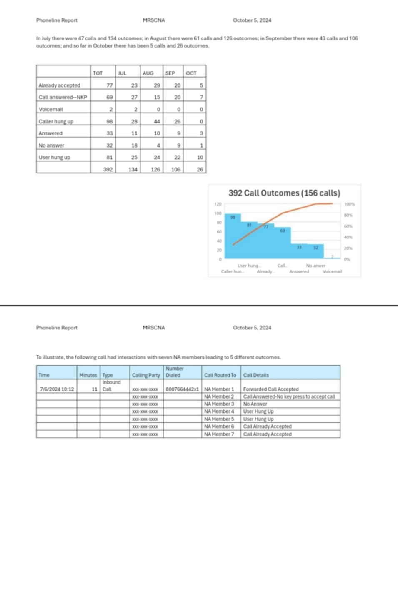

Convention:
Convention Committee Report - OCTOBER
Brittany O has volunteered to be Rover for this convention.
Rooms for convention will be reserved
All speakers are confirmed
All subcommittees are ready to go for fall convention.
-There aren’t very many topics on list received. LeeLee will be contacted to further discuss choices for workshops due to the fact that their were only 10-12 sent in list.
-MRSCNA CHAIR will print copies of correlating basic text readings for workshops
-Previous convention vice chair will continue to help current vice chair with taking over new position And with the program so that we can get it out before the week of convention.
-When Merchandise is open both Chair and Vice Chair of merchandise need to be there unless another approved money person (convention chairs, reg chairs, chair, vice chair, RD) is there to take their position over until they return. The expectation is that both be there when open if at all possible.
ONLY APPROVED PEOPLE HANDLE MONEY but you can have outside help in your positions to do things like carry boxes, work the door, do math, ect.
SPRING CONVENTION
PRESENTATION GUYS
⁃ Presentation guys who do presentations on the history of the Basic Text and the history of NA possibly to come to spring convention they would need an hour and a half blocked per presentation in assembly hall
⁃ We would have to find a gap in registration and work out mechanics.
⁃ We could have them in a 1-3 GAP ( 1:15-2:45) and then have Registration 3:00 - 5 ?
⁃ schedule less topic meetings during this time
⁃ Call for Artwork for spring needs put out with deadline of January 1st
SPIRIT OF LOVE
-Submissions to Web Servants.
Thank you- Tia M. Convention Secretary.

RD Report:

No Report Submitted

RDA Report:
No Report Submitted

P&A:
No Report Submitted

FINANCE:
Finance Subcommittee Report
See Appendix:
Treasurer Report
YTD Report
Finance Template

NEW BUSINESS:

No proposals were submitted

NAWS DONATION:
No donation at this time
NEXT REGIONAL SERVICE:

January 2025 RSC Order of the Day
01/04/25
ZOOM
Opening at 12:00pm
Reading of the Twelve Traditions of NA
Reading of the Twelve Concepts for NA Service
Reading of the Preamble
Introductions
Secretary’s Report (Reading of the Minutes from preceding RSC)
Treasurer I Report
Old Business
Area Reports
Open Sharing Session
New Area Motions/Proposals
Sub-committees
PR Umbrella Subcommittee
(Web Page
Phoneline
H&I
PR)
Convention Subcommittee

Will adjourn at 6:30 pm and reconvene at 9:00 am Sunday

01/05/2025
Representative Reports:
1. Regional Delegate (RD).
2. Regional Delegate Alternate (RD-Alt.)
P&A Sub-Committee
Finance
New Business
NAWS Donation
Set Agenda for Next RSC Meeting
Open Forum
Announcements
Closing Prayer

