REGISTRATION
CONVENTION REGISTRATION FEE
WEEKEND - $35

CONVENTION REGISTRATION HOURS

Front office:
Friday: 10 a.m. – 4:30 p.m.

Assembly Hall:
Friday: 7:00 – 8:30 p.m.
Saturday: 9:00 – 11:00 a.m.
1:00 – 4:30 p.m.

CREDIT CARDS ARE ACCEPTED FOR MERCHANDISE AND REGISTRATION-
Discover, American Express, Visa and MasterCard

Pay what you can NO ADDICT TURNED AWAY –
DONATIONS FOR NEWCOMERS ACCEPTED AT REGISTRATION

MERCHANDISE

CLASSROOM 2:
Friday: 2:00 - 4:00 p.m.
After Speaker Meeting

Saturday: 2:00-4:00 & 6:00-7:00 p.m.
After Speaker Meeting

Sunday: After Speaker Meeting

Speaker recordings can be heard on our YouTube channel: MRSCNA audio

Quiet Time is Midnight
Vocational 1 and the Craft House will be available for after-hour activities

CEDAR LAKES ROOM REGISTRATION AND MEAL TICKETS ARE AVAILABLE AT THE FRONT OFFICE
ALL BUILDINGS ARE NONSMOKING AND HANDICAPPED ACCESSIBLE

MARK YOUR CALENDARS…
“We Go All The Way”
Fall Convention
Presented by the
Mountaineer Regional Service Committee of Narcotics Anonymous

Oct. 25-27, 2024
Cedar Lakes
Ripley, WV

CONTACT INFO FOR MRSCNA CONVENTION
Cooper B. Chair (304) 661-0507
The contacts prefer texts, please
Greg Y. Vice Chair (304) 989-1493
mountaineer.region.convention@gmail.com

Mountaineer Region Helpline
1-800-766-4442
http://www.mrscna.org/

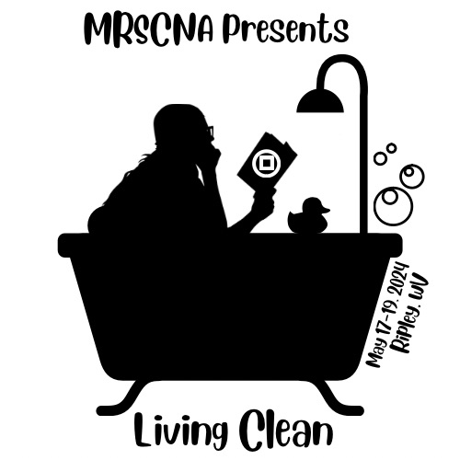

Presented by the
Mountaineer Regional Service Committee of Narcotics Anonymous
at
Cedar Lakes
Ripley, WV

“Living Clean”

May 17-19, 2024

(Pg. numbers are from Living Clean, the Journey Continues)

FRIDAY FRIDAY FRIDAY FRIDAY FRIDAY FRIDAY

5:00 - 6:00 pm | Dinner | Dining Hall
6:00 - 6:55 pm | Welcome meeting | Assembly Hall
7:00 - 8:00 pm | Steps 8 & 9  Why we stay, p.19  Setting ourselves apart, p.232  Sponsorship, p.193  Keeping it real, p.237  Awakening to our spirituality, p.46 | Vocational 1  Vocational 2  Assembly Hall Classroom 1  Craft house 1 Craft House 2  Craft House 3
8:30 pm | Speaker Meeting: Cindy R. – St. Albans, WV  Speaker Meeting: Mack M. – Hamilton. OH | Assembly Hall  Dining Hall
After Speaker | Marathon Meeting  Campfire Meeting | Vocational 1  Campfire Circle
12:00 am | Connection to others, p.37 | Craft House 1
SATURDAY SATURDAY SATURDAY SATURDAY SATURDAY
6:30 am | Morning Meditation | Vocational 1
7:30 - 8:15 am | Breakfast | Dining Hall
9:00 - 10:00 am | Step 12  LGBTQ+, Regardless of…  Surrender, p.48  Living Clean, p. 1  Spirituality is practical, p.59  Walking the walk, p.62 | Vocational 1  Vocational 2  Assembly Hall Classroom 1 Craft House 1  Craft House 2  Craft House 3
10:30 - 11:30 am | Step 10  RD Forum Who’s missing from our meetings?  Conscious contact (prayer and meditation), p.73  Creative action, p.76  Disability, p.10  Emotional and Spiritual crisis, p.110 | Vocational 1  Vocational 2  Assembly Hall Classroom 1 Craft House 1  Craft House 2  Craft House 3
Noon - 1:00 pm | Lunch | Dining Hall
1:15- 2:15 pm | Step 1  Steps 4 & 5  The 12 Concepts  Aging, p.113  Death and grief, p.115  Courage, p.120 | Vocational 1  Vocational 2  Assembly Hall Classroom 1 Craft House 1  Craft House 2  Craft House 3
2:30- 3:30 pm | Step 2  Steps 6 & 7  Step 11  Fellowship, p.126  Being a parent, p.145  Relationships, p.163 | Vocational 1  Vocational 2  Assembly Hall Classroom 1 Craft House 1  Craft House 2  Craft House 3
3:45- 4:45 pm | Step 3  Traditions  Beyond social acceptability, p.177  Stability (home group), p.185  Living our principals, p.222  Getting out of our own way, p.189 | Vocational 1  Vocational 2  Assembly Hall Classroom 1 Craft House 1  Craft House 2  Craft House 3
5:00 - 6:00 pm | Dinner | Dining Hall
6:45 - 8:00 pm | Recognition of States  Clean-time Countdown  Unity Prayer | Assembly Hall
8:30 pm | Speaker Meeting: Wilvena G.- NY  Speaker Meeting: Daniel M. – Jefferson, IN | Assembly Hall  Dining Hall
After Speaker | Dance  Marathon Meeting  Campfire Meeting | Assembly Hall  Vocational 1  Campfire Circle
12:00 am | Commitment, p.197 | Craft House 1
SUNDAY SUNDAY SUNDAY SUNDAY SUNDAY
6:30 am | Morning Meditation | Vocational 1
8:30 - 9:30 am | TOPIC MEETINGS  Leap of Faith, P.194  The gift of hope, p.215 | Vocational 1  Vocational 2
9:45 - 10:45 am | Brunch | Dining Hall
11 am | Speaker Meeting: Brittany O. – Beckley, WV | Assembly Hall

