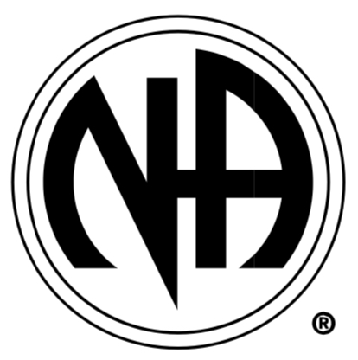

Drug Problem? Want to Stop? We Can Help!

Narcotics Anonymous

For the most updated meeting information, call the HELPLINE or visit our webpage.
24 HOUR HELPLINE NUMBER
1-800-766-4442 or 304-344-4442
www.MRSCNA.org
"That no addict seeking recovery need ever die."
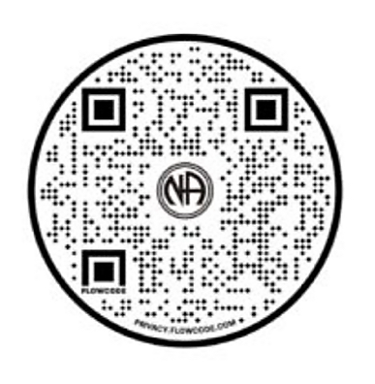
RSC PO Box 11121, Charleston, WV 25339

