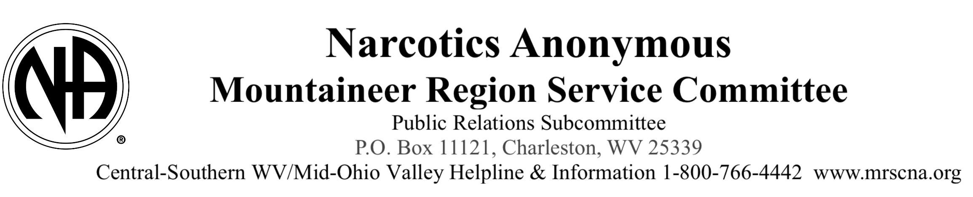
May 2025

Dear Fellow Recovery Associate,
We are writing to increase your awareness of Narcotics Anonymous and the current services and resources that NA now provides in the recovery community. We have new NA recovery literature that is available online, informational pamphlets and material about NA for professionals, and a variety of presentations that we can provide for you or your staff.

We have revised our NA Meetings Directory that is available on our website. The meeting directory is updated daily to provide the most accurate listing of NA Meetings. The directory can be searched by the day, city, zip code, or type of NA Meeting. The same list is available on our automated statewide helpline. The meeting directory can be downloaded and printed in multiple formats. We also provide a listing of all the virtual NA meetings hosted, primarily on a Zoom format.

Our statewide NA Helpline has a highly developed feature to connect a caller that wants to talk to another recovering addict directly to a NA volunteer near their location. Our Helpline volunteers are NA Members who are trained and willing to help the caller find recovery in Narcotics Anonymous. We have also added a feature to connect professionals calling for information about NA directly to a member of our Public Relations Committees.

Our Narcotics Anonymous literature has expanded to include several new books that help NA members live in recovery through application of the 12 Steps of Narcotics Anonymous. We have also developed informational pamphlets for NA Members that are new to NA, Young NA members, the parents of NA members, and members on medically assisted treatment. All the pamphlets are available on our website for free download. The books are available for sale as are bulk orders of the pamphlets.

Our Public Relations Committee is committed to providing information to the public and informing professionals about Narcotics Anonymous. We actively distribute NA literature, Helpline posters, and Helpline outreach contact cards to locations that are in contact with addicts. We provide an exhibit booth at most addiction treatment conferences and make panel presentations about Narcotics Anonymous recovery. We also facilitate roundtable meetings with treatment, healthcare, and correctional professionals to discuss issues related to Narcotics Anonymous recovery for their clients.

Please feel free to contact us if we can be of service in providing NA Resources. A local NA representative can contact you directly if you request. Additional sources of information are attached, and included below, that you may find helpful. We look forward to a mutually beneficial relationship

Thank You for your consideration,
The Mountaineer Regional Public Relations Subcommittee

Shenna R. - Chairperson
Tory B.- Vice Chairperson
1-(800) 766-4442
mountaineer.region.pr@gmail.com

Additional sources of information about Narcotics Anonymous
Central-Southern WV/Mid-OH Valley NA Website: https://www.mrscna.org/
Narcotics Anonymous World Services: https://na.org/resources-for-professionals/
NA online recovery literature: https://na.org/literature/recovery-literature-in-english-usa/

